Student Grade Management
System

Submitted By: Manisha Karmakar

Reg.number: 24BAI10737
Course / Subject: Programming in Java
Slot: B11+B12

Faculty: Murugeshwari K.

Objective:
The objective of this project is to develop a Java program to manage student marks. The program calculates total marks, percentage, and grade for 5 subjects and displays a student report using a menudriven system

Technologies Used
Java (JDK 17+)
IntelliJ IDEA

Class Design

Student.java
1)Variables:
name, rollNo, maths, science, english, computer, social, total, percentage, grade
2)Methods:
calculateTotal() → sums all subject marks calculatePercentage() → calculates percentage calculateGrade() → assigns grade based on percentage displayDetails() → prints student details

3)Main.java
Menu-driven program with options:
- Add Student
- Display All Students
- Exit

4)Algorithm / Program Flow
- Start program
- Display menu: Add Student / Display All Students / Exit
- Take user input
- If user selects Add Student:
i)Enter Name, Roll No, Marks for 5 subjects ii)Call calculateTotal(), calculatePercentage(), calculateGrade()
iii) Add student to list
- If user selects Display All Students:
i)Display Name, Roll No, Marks, Total, Percentage, and Grade
- Repeat menu until Exit

5)Testing / Sample Data Sample Students:
Name | Roll Maths  No | Science | English | Computer | Social Total | Percentage | Grade
Asha | 1 95 | 88 | 76 | 92 | 85 436 | 87.2% | B
Rohan | 2 78 | 82 | 69 | 85 | 80 394 | 78.8% | C
Priya | 3 55 | 62 | 58 | 60 | 59 294 | 58.8% | F
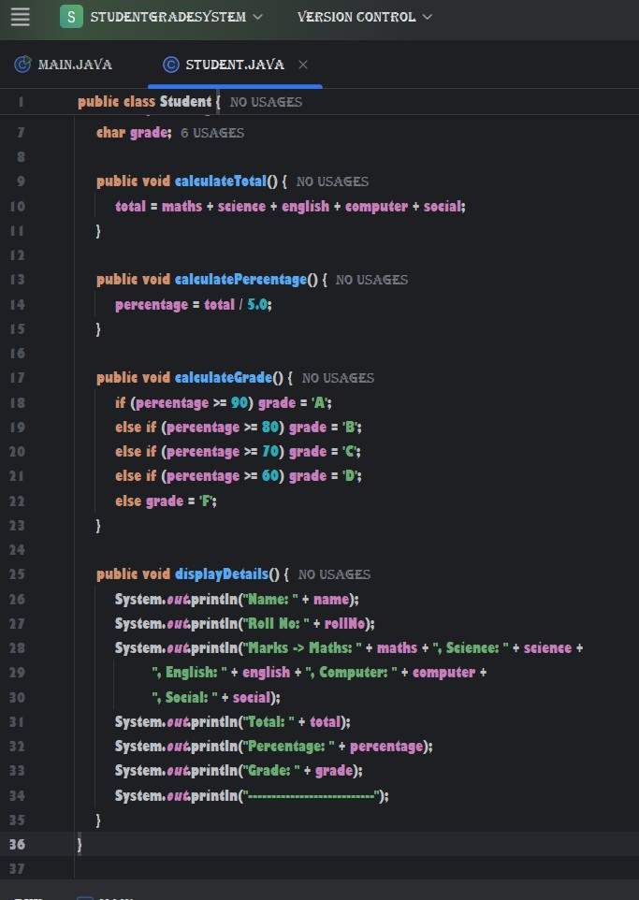
program_code
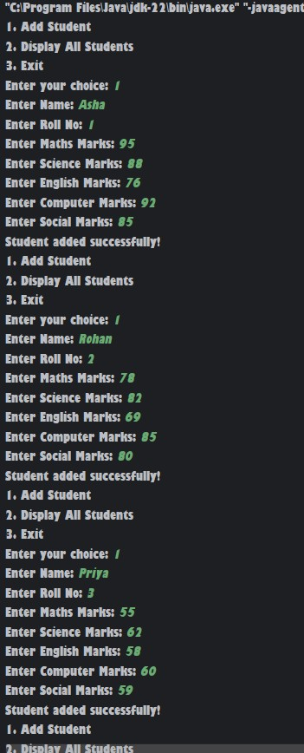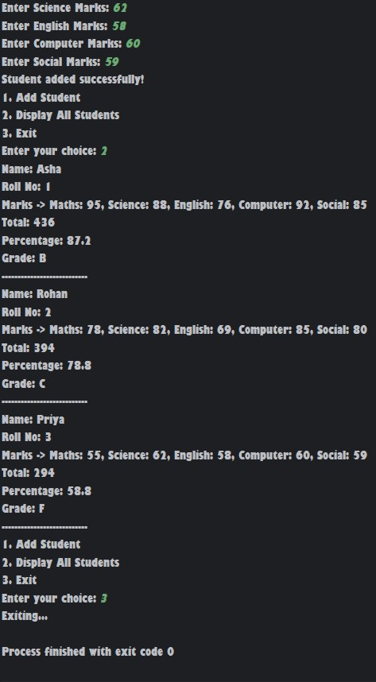 output

6)Conclusion
This project helped me understand object-oriented programming concepts in Java, such as classes, objects, methods, and ArrayList. It demonstrates a practical application of managing student grades in a simple, organized, and user-friendly way.

